UNITED STATES
SECURITIES AND EXCHANGE COMMISSION
WASHINGTON, DC 20549
FORM 8-K
CURRENT REPORT
PURSUANT TO SECTION 13 OR 15(D) OF THE SECURITIES EXCHANGE ACT OF 1934
Date of Report (Date of earliest event reported): June 4, 2024
_________________________
GoHealth, Inc.
(Exact name of registrant as specified in its charter)
_________________________
Delaware |  |  | 001-39390 |  |  | 85-0563805
(State or other jurisdiction of incorporation) |  |  | (Commission File Number) |  |  | (I.R.S. Employer Identification No.)
222 W Merchandise Mart Plaza Suite 1750 |  |  |  |  |  |  |  |  | 60654
Chicago, |  |  | Illinois
(Address of principal executive offices) |  |  |  |  |  |  |  |  | (Zip Code)
(312) 386-8200
(Registrant’s telephone number, including area code)
N/A
(Former name or former address, if changed since last report)
_________________________
Check the appropriate box below if the Form 8-K filing is intended to simultaneously satisfy the filing obligation of the registrant under any of the following provisions:
☐ |  |  | Written communications pursuant to Rule 425 under the Securities Act (17 CFR 230.425).
☐ |  |  | Soliciting material pursuant to Rule 14a-12 under the Exchange Act (17 CFR 240.14a-12).
☐ |  |  | Pre-commencement communications pursuant to Rule 14d-2(b) under the Exchange Act (17 CFR 240.14d-2(b)).
☐ |  |  | Pre-commencement communications pursuant to Rule 13e-4(c) under the Exchange Act (17 CFR 240.13e-4(c)).
Securities registered pursuant to Section 12(b) of the Act:
Title of each class |  |  |  |  |  | Trading Symbol(s) |  |  |  |  |  | Name of each exchange  on which registered
Class A Common Stock,  $0.0001 par value per share |  |  |  |  |  | GOCO |  |  |  |  |  | The Nasdaq Global Market
Indicate by check mark whether the registrant is an emerging growth company as defined in Rule 405 of the Securities Act of 1933 (§230.405 of this chapter) or Rule 12b-2 of the Securities Exchange Act of 1934 (§240.12b-2 of this chapter).
Emerging growth company ☐
If an emerging growth company, indicate by check mark if the registrant has elected not to use the extended transition period for complying with any new or revised financial accounting standards provided pursuant to Section 13(a) of the Exchange Act. ☐

Item 5.02. Departure of Directors or Certain Officers; Election of Directors; Appointment of Certain Officers; Compensatory Arrangements of Certain Officers.

Executive Transitions

On June 4, 2024, GoHealth, Inc. (the “Company”) announced the resignation of Jason Schulz as Chief Financial Officer. Mr. Schulz provided notice of this decision on May 31, 2024. Mr. Schulz will continue to serve as a non-executive, employed consultant through September 1, 2024, at which time his employment with the Company will end. Mr. Schulz’s resignation was not related to any disagreement with the Company on any matter related to its operations, financial reporting, policies, and/or practices.

The Company further announced the appointment of Chief Accounting Officer, Katherine O’Halloran, age 53, as the Interim Chief Financial Officer on June 4, 2024 while the Company searches for a permanent replacement. Ms. O’Halloran brings over 30 years of experience in executive accounting and finance roles. Prior to joining GoHealth in April 2023 as Chief Accounting Officer, Ms. O’Halloran served as Chief Financial Officer at VanEnkevort Tug & Barge, Inc., a marine transportation business, from January 2022 to April 2023. Prior to that, she spent 16 years at Great Lakes Dredge & Dock Corporation (Nasdaq:GLDD), the largest provider of dredging services in the United States, most recently as Vice President, Controller and Treasurer from 2013 to 2022.

Ms. O’Halloran holds a Bachelor’s degree in Accountancy from Northern Illinois University, has an MBA from St. Xavier University and is a Certified Public Accountant. Ms. O’Halloran does not have any family relationship with any director or executive officer of the Company, or any person nominated or chosen to become a director or executive officer of the Company, and there are no arrangements or understandings with any persons pursuant to which Ms. O’Halloran has been appointed to her position. There are no transactions between the Company and Ms. O’Halloran that would be required to be reported under Item 404(a) of Regulation S-K.

As part of Ms. O’Halloran’s role as Chief Accounting Officer, she earns an annual base salary of $325,000 and has an annual target cash bonus equal to 50% of her base salary. At the time of her hire, she was awarded equity in the form of Restricted Stock Units equal to 15,000 shares that vest equally over three years contingent on her continued employment with the Company. Additionally, she is entitled to equity awards on an annual basis at the discretion of the CEO and Board of Directors. The Board of Directors have not finalized additional compensation for Ms. O’Halloran for her role as Interim Chief Financial Officer.

Item 7.01. Regulation FD Disclosure.

On June 4, 2024, the Company issued a press release announcing the appointment of Ms. O’Halloran and the resignation of Mr. Schulz, a copy of which is furnished as Exhibit 99.1 hereto and incorporated into this Item 7.01 by reference.

The information in this Item 7.01 and Exhibit 99.1 shall not be deemed “filed” for purposes of Section 18 of the Exchange Act or otherwise subject to liabilities of that section. This information shall not be deemed to be incorporated by reference in any filing under the Securities Act of 1933, as amended, or the Exchange Act, except as shall be expressly set forth by specific reference to such disclosure in this Form 8-K in such filing.

Item 9.01. Financial Statements and Exhibits.

The following exhibits are included herewith:

Exhibit Number |  |  |  |  |  | Exhibit Description
99.1 |  |  |  |  |  | Press Release of GoHealth, Inc. dated June 4, 2024
104 |  |  |  |  |  | Cover Page Interactive Data File (formatted as inline XBRL)

SIGNATURES
Pursuant to the requirements of the Securities Exchange Act of 1934, the registrant has duly caused this report to be signed on its behalf by the undersigned hereunto duly authorized.

 |  |  |  |  |  | GOHEALTH, INC.
Date: |  |  | June 4, 2024 |  |  | By: |  |  | /s/ Bradley M. Burd
Brad Burd
Chief Legal Officer
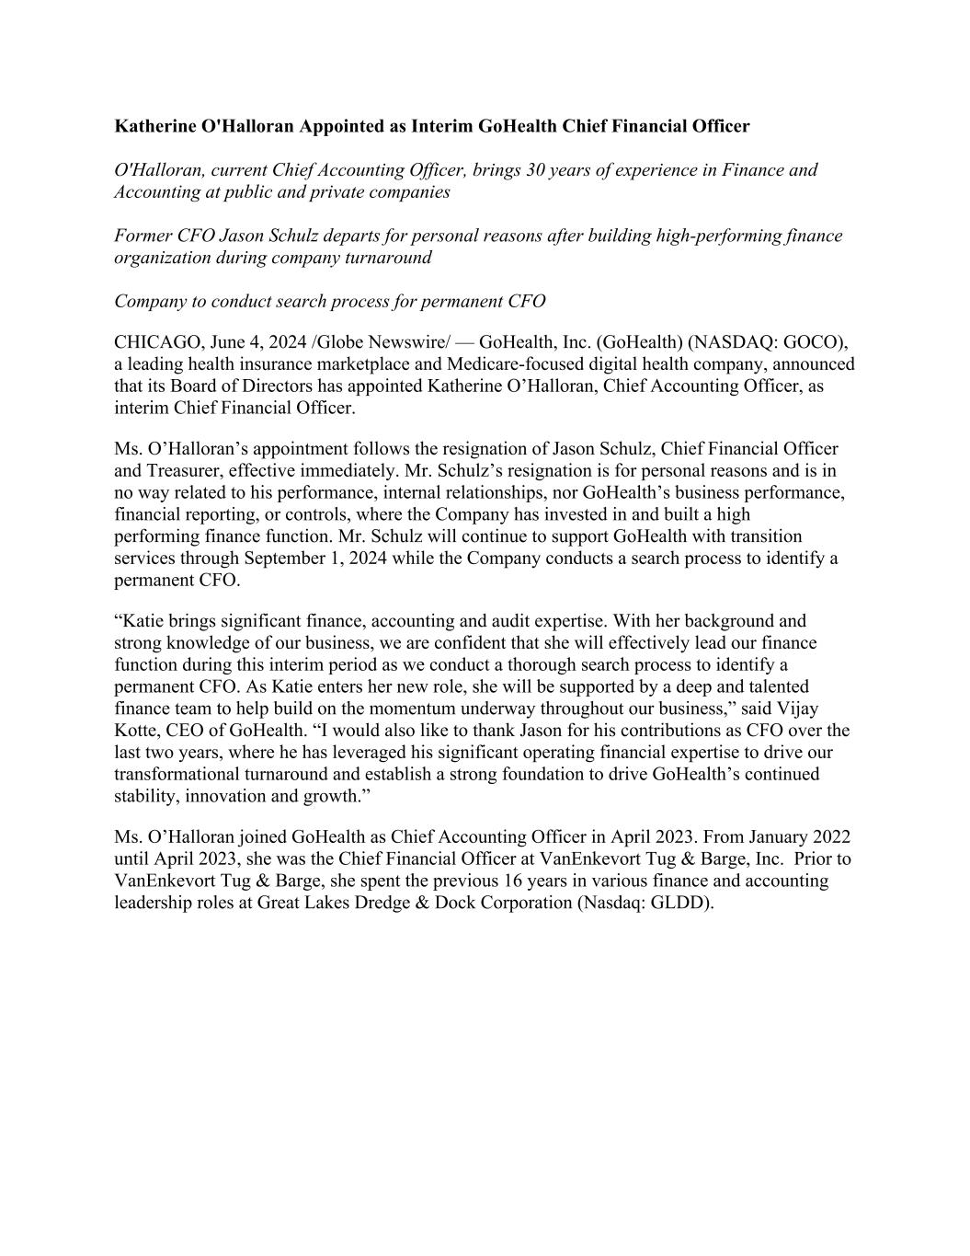

Katherine O'Halloran Appointed as Interim GoHealth Chief Financial Officer O'Halloran, current Chief Accounting Officer, brings 30 years of experience in Finance and Accounting at public and private companies Former CFO Jason Schulz departs for personal reasons after building high-performing finance organization during company turnaround Company to conduct search process for permanent CFO CHICAGO, June 4, 2024 /Globe Newswire/ — GoHealth, Inc. (GoHealth) (NASDAQ: GOCO), a leading health insurance marketplace and Medicare-focused digital health company, announced that its Board of Directors has appointed Katherine O’Halloran, Chief Accounting Officer, as interim Chief Financial Officer. Ms. O’Halloran’s appointment follows the resignation of Jason Schulz, Chief Financial Officer and Treasurer, effective immediately. Mr. Schulz’s resignation is for personal reasons and is in no way related to his performance, internal relationships, nor GoHealth’s business performance, financial reporting, or controls, where the Company has invested in and built a high performing finance function. Mr. Schulz will continue to support GoHealth with transition services through September 1, 2024 while the Company conducts a search process to identify a permanent CFO. “Katie brings significant finance, accounting and audit expertise. With her background and strong knowledge of our business, we are confident that she will effectively lead our finance function during this interim period as we conduct a thorough search process to identify a permanent CFO. As Katie enters her new role, she will be supported by a deep and talented finance team to help build on the momentum underway throughout our business,” said Vijay Kotte, CEO of GoHealth. “I would also like to thank Jason for his contributions as CFO over the last two years, where he has leveraged his significant operating financial expertise to drive our transformational turnaround and establish a strong foundation to drive GoHealth’s continued stability, innovation and growth.” Ms. O’Halloran joined GoHealth as Chief Accounting Officer in April 2023. From January 2022 until April 2023, she was the Chief Financial Officer at VanEnkevort Tug & Barge, Inc. Prior to VanEnkevort Tug & Barge, she spent the previous 16 years in various finance and accounting leadership roles at Great Lakes Dredge & Dock Corporation (Nasdaq: GLDD).

