SEC Form 3
FORM 3 | UNITED STATES SECURITIES AND EXCHANGE COMMISSION
 | Washington, D.C. 20549
 | Washington, D.C. 20549 |  | OMB APPROVAL
 | INITIAL STATEMENT OF BENEFICIAL OWNERSHIP OF SECURITIES
 | INITIAL STATEMENT OF BENEFICIAL OWNERSHIP OF SECURITIES |  | OMB Number: | 3235-0104
 |  |  | Estimated average burden
 | Filed pursuant to Section 16(a) of the Securities Exchange Act of 1934 |  | hours per response: | 0.5
or Section 30(h) of the Investment Company Act of 1940
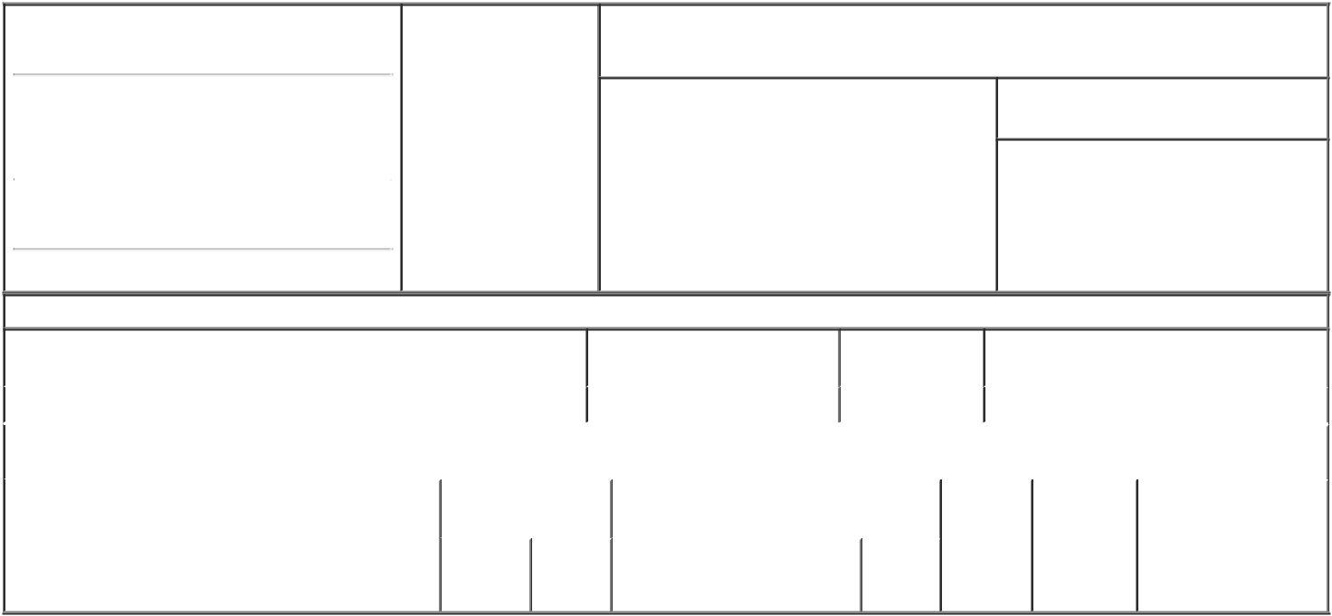

1. Name and Address of Reporting Person* |  |  | 2. Date of Event Requiring
 | Hargis Mike |  | Statement (Month/Day/Year)
 | Hargis Mike |  | 09/29/2023

3. Issuer Name and Ticker or Trading Symbol

GoHealth, Inc. [ GOCO ]

 | (Last) | (First) | (Middle)
 | 222 W MERCHANDISE MART PLAZA SUITE
1750
(Street)
 | CHICAGO | IL | 60654

- Relationship of Reporting Person(s) to Issuer (Check all applicable)
 | Director | 10% Owner
X | Officer (give title | Other (specify
X | below) | below)

Chief Operating Officer

- If Amendment, Date of Original Filed (Month/Day/Year)

- Individual or Joint/Group Filing (Check Applicable Line)
- Form filed by One Reporting Person

Form filed by More than One Reporting Person

(City) (State) (Zip)

Table I - Non-Derivative Securities Beneficially Owned

1. Title of Security (Instr. 4) |  |  |  | 2. Amount of Securities Beneficially | 3. Ownership Form: 4. Nature of Indirect Beneficial Ownership (Instr. 5)
 |  |  |  | Owned (Instr. 4) | Direct (D) or
 |  |  |  |  | Indirect (I) (Instr. 5)
Class A Common Stock |  |  |  | 166,666⁽¹⁾ | D
 |  | Table II - Derivative Securities Beneficially Owned
 | (e.g., puts, calls, warrants, options, convertible securities)
1. Title of Derivative Security (Instr. 4) |  | 2. Date Exercisable and 3. Title and Amount of Securities Underlying |  |  |  | 4. | 5. Ownership | 6. Nature of Indirect
 |  | Expiration Date |  | Derivative Security (Instr. 4) |  | Conversion | Form: Direct | Beneficial Ownership
 |  | (Month/Day/Year) |  |  |  | or Exercise | (D) or Indirect | (Instr. 5)
 |  |  |  |  |  | Price of | (I) (Instr. 5)
 |  |  |  |  | Amount | Price of | (I) (Instr. 5)
 |  |  |  |  | Amount | Derivative
 |  | Date | Expiration |  | or | Security
 |  | Date |  |  | Number
 |  | Exercisable | Date | Title | of Shares

Explanation of Responses:

- Includes an aggregate 144,444 restricted stock units (RSUs), which vest as to: (i) 44,444 RSUs in two remaining equal annual installments, with the first such installment vesting on September 9, 2024; (ii) 50,000 RSUs in two equal annual installments, with the first such installment vesting on March 21, 2024; and (iii) 50,000 RSUs in three substantially equal annual installments, with the first such installment vesting on August 9, 2024, each of which is subject to the reporting person's continuous employment through the applicable vesting dates.

Remarks:

Exhibit 24 - Power of Attorney.

/s/ Bradley Burd, Attorney-in-fact |  | 10/10/2023
** Signature of Reporting Person |  | Date

Reminder: Report on a separate line for each class of securities beneficially owned directly or indirectly.

* If the form is filed by more than one reporting person, see Instruction 5 (b)(v).

- Intentional misstatements or omissions of facts constitute Federal Criminal Violations See 18 U.S.C. 1001 and 15 U.S.C. 78ff(a). Note: File three copies of this Form, one of which must be manually signed. If space is insufficient, see Instruction 6 for procedure.
Persons who respond to the collection of information contained in this form are not required to respond unless the form displays a currently valid OMB Number.



