As filed with the Securities and Exchange Commission on March 6, 2025

Registration No. 333-

UNITED STATES
SECURITIES AND EXCHANGE COMMISSION
Washington, D.C. 20549

FORM S-8

REGISTRATION STATEMENT UNDER
THE SECURITIES ACT OF 1933

GoHealth, Inc.
(Exact name of registrant as specified in its charter)
DELAWARE  (State or other jurisdiction of incorporation or organization) |  |  |  |  |  | 85-0563805  (IRS Employer Identification No.)

222 W Merchandise Mart Plaza, Suite 1750, Chicago, Illinois 60654
(Address of Principal Executive Offices) (ZIP Code)

GOHEALTH, INC. AMENDED AND RESTATED 2020 INCENTIVE AWARD PLAN
GOHEALTH, INC. 2020 EMPLOYEE STOCK PURCHASE PLAN
(Full title of the plan)

BRADLEY BURD
Chief Legal Officer
GoHealth, Inc.
222 W Merchandise Mart Plaza, Suite 1750
Chicago, Illinois 60654
(Name and address of agent for service)

(312) 386-8200
(Telephone number, including area code, of agent for service)

Indicate by check mark whether the registrant is a large accelerated filer, an accelerated filer, a non-accelerated filer, a smaller reporting company or an emerging growth company. See the definitions of “large accelerated filer,” “accelerated filer,” “smaller reporting company,” and “emerging growth company” in Rule 12b-2 of the Exchange Act of 1934.

Large accelerated filer |  |  | ☐ |  |  |  |  |  | Accelerated filer |  |  | ☐
Non-accelerated filer |  |  | ☒ |  |  |  |  |  | Smaller reporting company |  |  | ☒
 |  |  |  |  |  |  |  |  | Emerging growth company |  |  | ☐

If an emerging growth company, indicate by check mark if the registrant has elected not to use the extended transition period for complying with any new or revised financial accounting standards provided pursuant to Section 7(a)(2)(B) of the Securities Act. ☐

EXPLANATORY NOTE

This Registration Statement on Form S-8 is being filed by GoHealth, Inc. (the “Company”) with the Securities and Exchange Commission (the “Commission”) for the purpose of registering an additional 1,253,129 shares of the Company’s Class A Common Stock, par value $0.0001 per share (“Common Stock”), issuable under the following employee benefit plans: (i) the Company’s Amended and Restated 2020 Incentive Award Plan, which, as a result of the operation of an automatic annual increase provision therein, added 1,150,198 shares of Common Stock, and (ii) the Company’s 2020 Employee Stock Purchase Plan, which, as a result of the operation of an automatic annual increase provision therein, added 102,931 shares of Common Stock.

Pursuant to Instruction E of Form S-8, the contents of the Registration Statements on Form S-8 filed with the Commission on July 15, 2020 (File No. 333-239879), February 10, 2021 (File No. 333-252962), March 23, 2022 (File No. 333-263787), June 6, 2022 (File No. 333-265442), January 13, 2023 (File No. 333-269223), and March 20, 2024 (file No. 333-278112) are incorporated by reference herein; except for Items 3 and 8 which are being updated by this Registration Statement.

PART II
INFORMATION REQUIRED IN THE REGISTRATION STATEMENT

Item 3. Incorporation of Documents by Reference.

The following documents, which have been filed with the Commission by the Company are incorporated in this Registration Statement by reference (excluding any portions of such documents that have been “furnished” but not “filed” for purposes of the Securities Exchange Act of 1934, as amended (the “Exchange Act”)):

1.The Registrant’s Annual Report on Form 10-K for the fiscal year ended December 31, 2024, filed with the Commission on February 27, 2025; and

2.The description of the Company’s Common Stock contained in the Company’s Registration Statement on Form 8-A dated July 15, 2020 (File No. 001-39390) filed under the Exchange Act, including any amendment or report filed for the purpose of updating such description.

All documents subsequently filed by the Company with the Commission pursuant to Sections 13(a), 13(c), 14 or 15(d) of the Exchange Act after the date of this Registration Statement and prior to the filing of a post-effective amendment to this Registration Statement which indicates that all securities offered hereby have been sold or which deregisters all securities then remaining unsold, shall be deemed to be incorporated by reference herein and to be a part hereof from the respective dates of filing of such documents (such documents, and the documents enumerated above, being hereinafter referred to as “Incorporated Documents”).

Any statement contained in an Incorporated Document shall be deemed to be modified or superseded for purposes of this Registration Statement to the extent that a statement contained herein or in any other subsequently filed Incorporated Document modifies or supersedes such statement. Any such statement so modified or superseded shall not be deemed, except as so modified or superseded, to constitute a part of this Registration Statement.

Item 8. Exhibits.

The Exhibits listed on the accompanying Index to Exhibits are filed as part hereof, or incorporated by reference into, this Registration Statement. See Exhibit Index below.

EXHIBIT INDEX

Exhibit Number |  |  |  |  |  | Exhibit Index
4.1 |  |  |  |  |  | Amended and Restated Certificate of Incorporation of GoHealth, Inc. (incorporated by reference to Exhibit 3.1 to the Company’s Quarterly Report on Form 10-Q (File No. 001-39390), filed on August 20, 2020 with the Commission)
4.2 |  |  |  |  |  | Certificate of Amendment to Amended and Restated Certificate of Incorporation of GoHealth, Inc. (incorporated by reference to Exhibit 3.1 to the Company’s Current Report on Form 8-K (File No. 001-39390), filed on November 18, 2022 with the Commission)
4.3 |  |  |  |  |  | Amended and Restated Bylaws of GoHealth, Inc. (incorporated by reference to Exhibit 3.2 to the Quarterly Report on Form 10-Q (File No. 001-39390), filed on August 20, 2020 with the Commission)
5.1* |  |  |  |  |  | Opinion of Sidley Austin LLP
23.1* |  |  |  |  |  | Consent of Ernst & Young LLP
23.2* |  |  |  |  |  | Consent of Sidley Austin LLP (included in Exhibit 5.1)
24.1* |  |  |  |  |  | Power of Attorney (included on the signature page hereto)
99.1 |  |  |  |  |  | GoHealth, Inc. Amended and Restated 2020 Incentive Award Plan (incorporated by reference to Appendix A to the Company’s Definitive Proxy Statement, filed on April 13, 2022 with the Commission).
99.2 |  |  |  |  |  | GoHealth, Inc. 2020 Employee Stock Purchase Plan (incorporated by reference to Exhibit 10.7 to the Company’s Registration Statement (File No. 333-239287), filed on July 8, 2020 with the Commission).
107* |  |  |  |  |  | Filing Fee Table
__________________
* Filed herewith.

SIGNATURES

Pursuant to the requirements of the Securities Act of 1933, the registrant certifies that it has reasonable grounds to believe that it meets all of the requirements for filing on Form S-8 and has duly caused this Registration Statement to be signed on its behalf by the undersigned, thereunto duly authorized, in the City of Chicago, State of Illinois, on March 6, 2025.
 |  |  | GOHEALTH, INC.
 |  |  | By |  |  | /s/ Vijay Kotte
 |  |  |  |  |  | Vijay Kotte
 |  |  |  |  |  | Chief Executive Officer

POWER OF ATTORNEY

Each of the undersigned officers and directors of GoHealth, Inc. hereby constitutes and appoints Vijay Kotte and Brendan Shanahan, and each of them any of whom may act without joinder of the other, the individual’s true and lawful attorneys-in-fact and agents, each with full power of substitution and resubstitution, for the person and in his or her name, place and stead, in any and all capacities, to sign this Registration Statement and any and all amendments (including post-effective amendments) to this Registration Statement and all documents relating thereto, and to file the same, with all exhibits thereto, and other documents in connection therewith, with the Securities and Exchange Commission, granting unto such attorneys-in-fact and agents, each acting alone, full power and authority to do and perform each and every act and thing necessary or advisable to be done in and about the premises, as fully to all intents and purposes as such person might or could do in person, hereby ratifying and confirming all that such attorneys-in-fact and agents, each acting alone, or such person’s substitute or substitutes, lawfully may do or cause to be done by virtue hereof.

Pursuant to the requirements of the Securities Act of 1933, this Registration Statement has been signed by the following persons in the capacities and on the dates indicated.

Signature |  |  |  |  |  | Title |  |  |  |  |  | Date
/s/ Vijay Kotte |  |  |  |  |  | Chief Executive Officer and Director (Principal Executive Officer) |  |  |  |  |  | March 6, 2025
Vijay Kotte
/s/ Brendan Shanahan |  |  |  |  |  | Chief Financial Officer (Principal Financial and Accounting Officer) |  |  |  |  |  | March 6, 2025
Brendan Shanahan
/s/ Clinton P. Jones |  |  |  |  |  | Director |  |  |  |  |  | March 6, 2025
Clinton P. Jones

/s/ Brandon M. Cruz |  |  |  |  |  | Director |  |  |  |  |  | March 6, 2025
Brandon M. Cruz
/s/ David Fisher |  |  |  |  |  | Director |  |  |  |  |  | March 6, 2025
David Fisher
/s/ Jeremy W. Gelber |  |  |  |  |  | Director |  |  |  |  |  | March 6, 2025
Jeremy W. Gelber
/s/ Karolina Hanna Hilu |  |  |  |  |  | Director |  |  |  |  |  | March 6, 2025
Karolina Hanna Hilu

/s/ Abhiraj R. Modi |  |  |  |  |  | Director |  |  |  |  |  | March 6, 2025
Abhiraj R. Modi

/s/ Alexander E. Timm |  |  |  |  |  | Director |  |  |  |  |  | March 6, 2025
Alexander E. Timm
/s/ Alan Wheatley |  |  |  |  |  | Director |  |  |  |  |  | March 6, 2025
Alan Wheatley

Exhibit 107

CALCULATION OF FILING FEE TABLE

FORM S-8
(Form Type)

GOHEALTH, INC.
(Exact Name of Registrant as Specified in its Charter)

Table I: Newly Registered Securities

Plan |  |  | Security Type |  |  | Security Class Title |  |  | Fee Calculation Rule |  |  | Amount Registered(1) |  |  | Proposed Maximum Offering Price Per Unit |  |  | Maximum Aggregate Offering Price |  |  | Fee Rate |  |  | Amount of Registration Fee
Amended and Restated 2020 Incentive Award Plan |  |  | Equity |  |  | Class A Common Stock, par value $0.0001 per share |  |  | Rule 457(c) and 457(h) |  |  | 1,150,198 (2) |  |  | $14.33(4) |  |  | $ | 16,482,337.34 |  | 0.0001531 |  |  | $ | 2,523.45
2020 Employee Stock Purchase Plan |  |  | Equity |  |  | Class A Common Stock, par value $0.0001 per share |  |  | Rule 457(c) and 457(h) |  |  | 102,931 (3) |  |  | $14.33(4) |  |  | $ | 1,475,001.23 |  | 0.0001531 |  |  | $ | 225.82
 |  |  | Total Offering Amounts |  |  |  |  |  |  |  |  |  |  |  |  |  |  | $ | 17,957,338.57 |  |  |  |  | $ | 2,749.27
 |  |  | Total Fee Offsets |  |  |  |  |  |  |  |  |  |  |  |  |  |  |  |  |  |  |  |  | $—
 |  |  | Net Fee Due |  |  |  |  |  |  |  |  |  |  |  |  |  |  |  |  |  |  |  |  | $ | 2,749.27

(1) Pursuant to Rule 416(a) promulgated under the Securities Act of 1933, as amended (the “Securities Act”), this Registration Statement shall also cover any additional shares of Class A Common Stock, par value $0.0001 per share (“Common Stock”), of GoHealth, Inc. (the “Company”) that become issuable under the Company’s Amended and Restated 2020 Incentive Award Plan (the “2020 Plan”) and the Company’s 2020 Employee Stock Purchase Plan (the “2020 ESPP”) by reason of any stock dividend, stock split, recapitalization or other similar transaction effected without receipt of consideration that increases the number of outstanding shares of Common Stock.
(2) Represents 1,150,198 additional shares of the Company’s Common Stock that became available for issuance on January 1, 2025 under the 2020 Plan, pursuant to the terms of the 2020 Plan.
(3) Represents 102,931 additional shares of the Company’s Common Stock that became available for issuance on January 1, 2025 under the 2020 ESPP, pursuant to the terms of the 2020 ESPP.
(4) This estimate is made pursuant to Rule 457(c) and Rule 457(h) of the Securities Act solely for purposes of calculating the registration fee. The Proposed Maximum Offering Price Per Unit for shares available for future grant is the average of the high and low prices for the registrant’s Common Stock as reported on The Nasdaq Global Select Market on February 28, 2025.

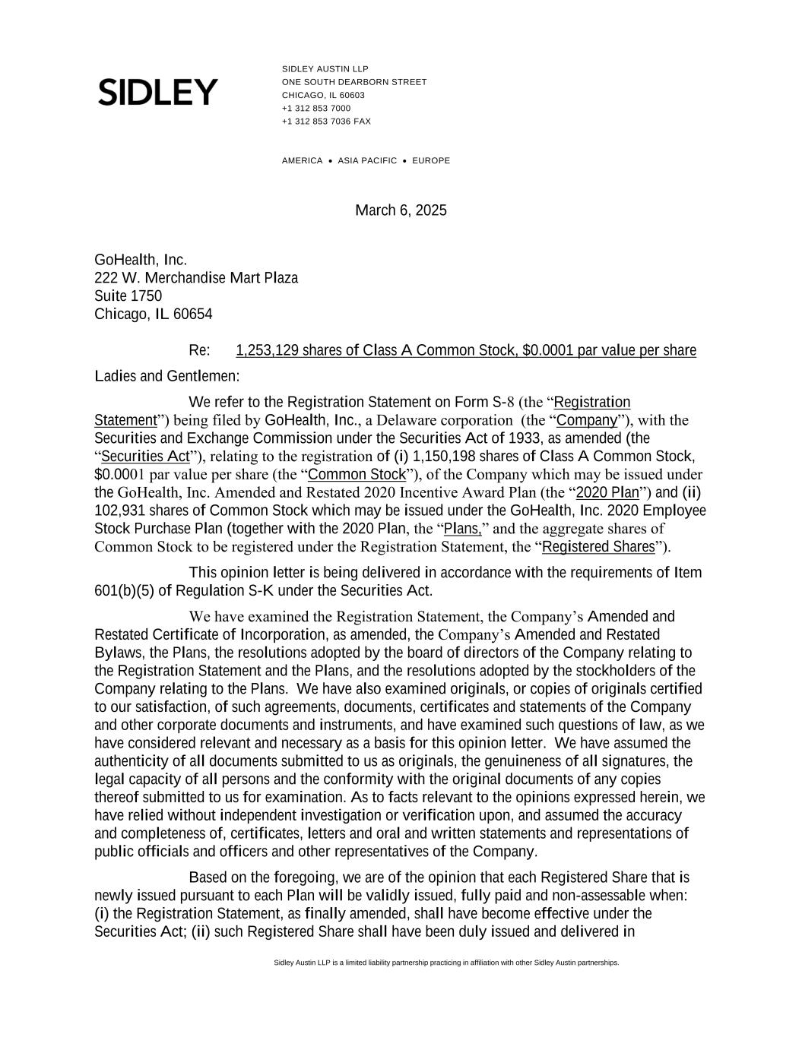

SIDLEY AUSTIN LLP ONE SOUTH DEARBORN STREET CHICAGO, IL 60603 +1 312 853 7000 +1 312 853 7036 FAX AMERICA • ASIA PACIFIC • EUROPE Sidley Austin LLP is a limited liability partnership practicing in affiliation with other Sidley Austin partnerships. March 6, 2025 GoHealth, Inc. 222 W. Merchandise Mart Plaza Suite 1750 Chicago, IL 60654 Re: 1,253,129 shares of Class A Common Stock, $0.0001 par value per share Ladies and Gentlemen: We refer to the Registration Statement on Form S-8 (the “Registration Statement”) being filed by GoHealth, Inc., a Delaware corporation (the “Company”), with the Securities and Exchange Commission under the Securities Act of 1933, as amended (the “Securities Act”), relating to the registration of (i) 1,150,198 shares of Class A Common Stock, $0.0001 par value per share (the “Common Stock”), of the Company which may be issued under the GoHealth, Inc. Amended and Restated 2020 Incentive Award Plan (the “2020 Plan”) and (ii) 102,931 shares of Common Stock which may be issued under the GoHealth, Inc. 2020 Employee Stock Purchase Plan (together with the 2020 Plan, the “Plans,” and the aggregate shares of Common Stock to be registered under the Registration Statement, the “Registered Shares”). This opinion letter is being delivered in accordance with the requirements of Item 601(b)(5) of Regulation S-K under the Securities Act. We have examined the Registration Statement, the Company’s Amended and Restated Certificate of Incorporation, as amended, the Company’s Amended and Restated Bylaws, the Plans, the resolutions adopted by the board of directors of the Company relating to the Registration Statement and the Plans, and the resolutions adopted by the stockholders of the Company relating to the Plans. We have also examined originals, or copies of originals certified to our satisfaction, of such agreements, documents, certificates and statements of the Company and other corporate documents and instruments, and have examined such questions of law, as we have considered relevant and necessary as a basis for this opinion letter. We have assumed the authenticity of all documents submitted to us as originals, the genuineness of all signatures, the legal capacity of all persons and the conformity with the original documents of any copies thereof submitted to us for examination. As to facts relevant to the opinions expressed herein, we have relied without independent investigation or verification upon, and assumed the accuracy and completeness of, certificates, letters and oral and written statements and representations of public officials and officers and other representatives of the Company. Based on the foregoing, we are of the opinion that each Registered Share that is newly issued pursuant to each Plan will be validly issued, fully paid and non-assessable when: (i) the Registration Statement, as finally amended, shall have become effective under the Securities Act; (ii) such Registered Share shall have been duly issued and delivered in

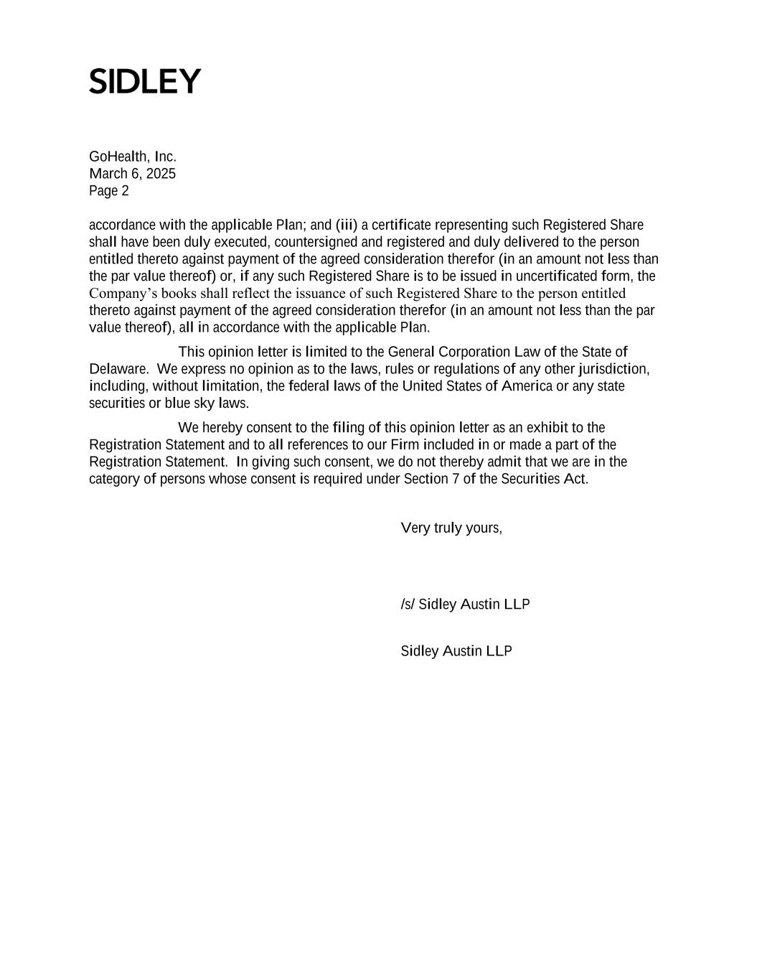
GoHealth, Inc. March 6, 2025 Page 2 accordance with the applicable Plan; and (iii) a certificate representing such Registered Share shall have been duly executed, countersigned and registered and duly delivered to the person entitled thereto against payment of the agreed consideration therefor (in an amount not less than the par value thereof) or, if any such Registered Share is to be issued in uncertificated form, the Company’s books shall reflect the issuance of such Registered Share to the person entitled thereto against payment of the agreed consideration therefor (in an amount not less than the par value thereof), all in accordance with the applicable Plan. This opinion letter is limited to the General Corporation Law of the State of Delaware. We express no opinion as to the laws, rules or regulations of any other jurisdiction, including, without limitation, the federal laws of the United States of America or any state securities or blue sky laws. We hereby consent to the filing of this opinion letter as an exhibit to the Registration Statement and to all references to our Firm included in or made a part of the Registration Statement. In giving such consent, we do not thereby admit that we are in the category of persons whose consent is required under Section 7 of the Securities Act. Very truly yours, /s/ Sidley Austin LLP Sidley Austin LLP

Exhibit 23.1

Consent of Independent Registered Public Accounting Firm

We consent to the incorporation by reference in the Registration Statement (Form S-8) pertaining to the GoHealth, Inc. Amended and Restated 2020 Incentive Award Plan, and the GoHealth, Inc. 2020 Employee Stock Purchase Plan of our report dated February 27, 2025, with respect to the consolidated financial statements of GoHealth, Inc. included in its Annual Report (Form 10-K) for the year ended December 31, 2024, filed with the Securities and Exchange Commission.

/s/ Ernst & Young LLP

Chicago, Illinois
March 6, 2025

