SEC Form 3
FORM 3 | UNITED STATES SECURITIES AND EXCHANGE COMMISSION
 | Washington, D.C. 20549
 | Washington, D.C. 20549 |  | OMB APPROVAL
 | INITIAL STATEMENT OF BENEFICIAL OWNERSHIP OF SECURITIES
 | INITIAL STATEMENT OF BENEFICIAL OWNERSHIP OF SECURITIES |  | OMB Number: | 3235-0104
 |  |  | Estimated average burden
 | Filed pursuant to Section 16(a) of the Securities Exchange Act of 1934 |  | hours per response: | 0.5
or Section 30(h) of the Investment Company Act of 1940
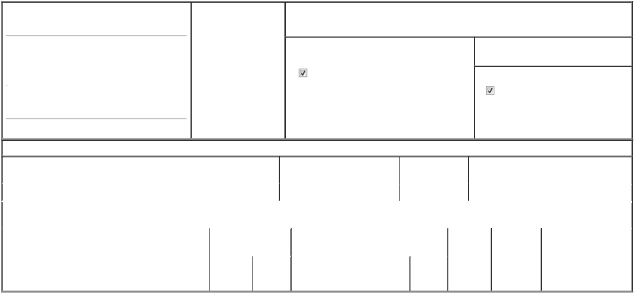

1. Name and Address of Reporting Person* |  |  | 2. Date of Event Requiring
 | OHalloran Katherine M |  | Statement (Month/Day/Year)
 | OHalloran Katherine M |  | 06/04/2024

3. Issuer Name and Ticker or Trading Symbol

GoHealth, Inc. [ GOCO ]

 | (Last) | (First) | (Middle)
 | 222 W MERCHANDISE MART PLAZA
 | SUITE 1750
(Street)
 | CHICAGO | IL | 60654

- Relationship of Reporting Person(s) to Issuer (Check all applicable)
Director 10% Owner

Officer (give title Other (specify

below) below)

Interim CFO

- If Amendment, Date of Original Filed (Month/Day/Year)

- Individual or Joint/Group Filing (Check Applicable Line)

Form filed by One Reporting Person

Form filed by More than One Reporting Person

(City) (State) (Zip)

Table I - Non-Derivative Securities Beneficially Owned

1. Title of Security (Instr. 4) |  |  |  | 2. Amount of Securities Beneficially | 3. Ownership Form: 4. Nature of Indirect Beneficial Ownership (Instr. 5)
 |  |  |  | Owned (Instr. 4) | Direct (D) or
 |  |  |  |  | Indirect (I) (Instr. 5)
Class A Common Stock |  |  |  | 43,534⁽¹⁾ | D
 |  | Table II - Derivative Securities Beneficially Owned
 | (e.g., puts, calls, warrants, options, convertible securities)
1. Title of Derivative Security (Instr. 4) |  | 2. Date Exercisable and 3. Title and Amount of Securities Underlying |  |  |  | 4. | 5. Ownership | 6. Nature of Indirect
 |  | Expiration Date |  | Derivative Security (Instr. 4) |  | Conversion | Form: Direct | Beneficial Ownership
 |  | (Month/Day/Year) |  |  |  | or Exercise | (D) or Indirect | (Instr. 5)
 |  |  |  |  |  | Price of | (I) (Instr. 5)
 |  |  |  |  | Amount | Price of | (I) (Instr. 5)
 |  |  |  |  | Amount | Derivative
 |  | Date | Expiration |  | or | Security
 |  | Date |  |  | Number
 |  | Exercisable | Date | Title | of Shares

Explanation of Responses:

- Includes an aggregate 40,000 restricted stock units (RSUs), which vest as to: (i) 10,000 RSUs in two remaining equal annual installments, with the first such installment vesting on June 1, 2025 and (ii) 30,000 RSUs in three equal annual installments, with the first such installment vesting on April 1, 2025, each of which is subject to the reporting person's continuous employment through the applicable vesting dates.

Remarks:

Exhibit 24 - Power of Attorney.

/s/ Katherine O'Halloran |  | 06/12/2024
** Signature of Reporting Person |  | Date

Reminder: Report on a separate line for each class of securities beneficially owned directly or indirectly.

* If the form is filed by more than one reporting person, see Instruction 5 (b)(v).

- Intentional misstatements or omissions of facts constitute Federal Criminal Violations See 18 U.S.C. 1001 and 15 U.S.C. 78ff(a). Note: File three copies of this Form, one of which must be manually signed. If space is insufficient, see Instruction 6 for procedure.
Persons who respond to the collection of information contained in this form are not required to respond unless the form displays a currently valid OMB Number.



